Price-List Differential Blood-cell Counter

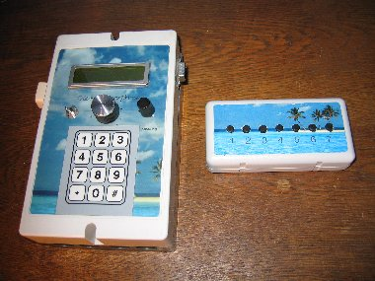
Metamorphosis as a Blood-cell counter
Including 128 KB CPU, LCD-Display with 2*16 Characters, Keyboard with 12 Keys, external Keypad for Counting, 4 Analog Inputs, 4 Digital Potential-free Inputs, 12 Step Program-Switch, serial Interface for Data-Upload and Download, Programming-Adapter and Data-Cable.
Software and Documentation for all Applications on CD. Free Update of new Software via the Internet.
Basic-Version: 279 Euro

Extensions:

Battery-Back-up by 6 NimH-Cells with charging-Unit (including Cells) 35 Euro
External 12V Moving-Detector 15 Euro

Integrated Noise-Detector for Alarm-System 10 Euro

Loud Horn for Alarm-System 10 Euro

Modified Mobile-phone Data-cable (for Siemens Mobile-Phones S25, C35, S45…) 15 Euro
(for Alarm-Notification etc)
Loading-Output for the Mobile-Telephone 5 Euro

Relay (max. 6) for Alarm-Notification (external Horn or Lamp) each 3 Euro

Transport:
Europe: 9 Euro
Outside Europe: 18 Euro

Delivery Time: approx.14 days (Europe)

It is a Non-Profit-Project and the yield is send to the Project mentioned in the Internet

If you need other Functions, let us know and we can try to implement it. Necessary Software for download and cable can be delivered.

For more information go to the Internet at www.Alternative-Technology.de or contact us

Contact:
Stefan Schranner
Alternative Technologie
Frau-Holle-Weg 28
97084 Würzburg
Tel: +49 (0)931 72353
Mobil: +49 (0)170 6343070
Internet: www.alternative-technologie.de
Email: StefanSchranner@yahoo.de

